SHORT COMMUNICATIONS
Side chain engineering on D18 polymers yields 18.74% power conversion efficiency
Xianyi Meng^{1, 2, ‡}, Ke Jin^{1, ‡}, Zuo Xiao^{1, †}, and Liming Ding^{1, 2, †} (Please mark “†” after the Corresponding author, “‡” after the equally contributed authors)
¹Institute of Semiconductors, Chinese Academy of Sciences, Beijing 100083, China
²Institute of Microelectronics, Tsinghua University, Beijing 100084, China

- No need for Abstract and Key words.
- No need for Sections. If necessary, key sentences could be displayed in bold.
- Short Communications provide rapid and brief report of a novel finding or an important breakthrough in research, and are expected to be less than 2000 words with 1–2 displayed items.

Donor–acceptor (D–A) conjugated copolymers containing fused-ring acceptor units demonstrate outstanding performance in organic solar cells (OSCs)^{[1−13]}. We have invented highly efficient D–A copolymer donors D18 and D18-Cl by using a fused-ring acceptor unit, dithieno [3',2':3,4;2'',3'':5,6]benzo[1,2-c][1,2,5]thiadiazole (DTBT)^{[1, 2]}. OSCs with D18 or D18-Cl gave power conversion efficiencies (PCEs) of 18.56% and 18.69%, respectively^{[3, 4]}. Side chain engineering is an effective approach to improve the performance of conjugated polymers in optoelectronic devices^{[14−16]}. The alkyl side chains not only determine polymers’ solubility, but also influence their crystallinity and mobility. In this work, we develop two efficient donors D18-B and D18-Cl-B via side chain engineering on D18 polymers (Fig. 1(a)). These donors offer PCEs up to 18.74% (certified 18.2%) in ternary OSCs.
The structural difference between D18 and D18-B (or D18-Cl vs D18-Cl-B) polymers is the alkyl chains on thiophene bridge units.…. The best D18-Cl-B:N3:PC61BM (1 : 1.4 : 0.2) cells offered a PCE of 18.74%, with a V_{oc} of 0.836 V, a J_{sc} of 28.50 mA/cm² and a FF of 78.7% (Fig. 1(b), Table 1)….
……..
……..
……..
In short, we create two polymer donors D18-B and D18- l-B via side chain engineering on D18 polymers. PCEs of 18.53% and 18.74% were achieved, respectively, demonstrating their potential in organic solar cells.
(Times New Roman, word size: 12)

‡ Xianyi Meng and Ke Jin contributed equally to this work.
† Correspondence to: Z Xiao, xiaoz@nanoctr.cn; L M Ding, ding@nanoctr.cn (Corresponding author)
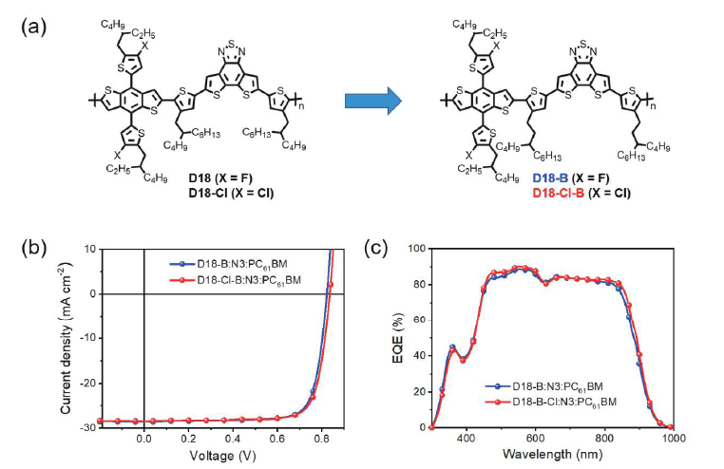
Fig. 1. (Color online) The measured and simulated S parameters.
- The axis labels should be given in the form of “variable (unit)".

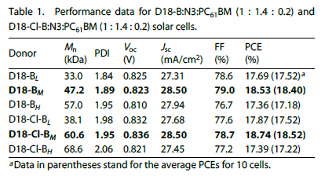
- Three-line table should be used.

Acknowledgments (Optional)
- The scientific contributions from other people or groups are acknowledged here.
- Financial supports are given here.

Appendix A. Supplementary material (Optional)

Supplementary material associated with this article can be found, in the online version, at https://doi.org/10.1088/1674-4926//********.

References
- Cui J, Chen L, Kang C L, et al. A high-linearity InGaP/GaAs HBT power amplifier for IEEE 802.11a/n. J Semicond, 2013, 34(6): 065001(Journal)
- Hur J, Kim H, Lee O, et al. Multi-level LINC transmitter with non-isolated power combiner. Electron Lett, 2013, 49(25): 1624 (Journal)
- Lazavi B. Design of integrated circuits for optical communications. Boston: McGraw-Hill, 2003 (Book)
- Yoo S J, Ravindran A, Ismail M. A low voltage CMOS transresistance-based variable gain amplifier. IEEE International Symposium on Circuits and Systems, 2004: 809 (Conference publication)
- Guo Z Y. Optical readout infrared imaging system at room temperature. PhD Dissertation, University of Science and Technology of China, 2005 (in Chinese) (Dissertation)
- Sato K. Multi-wavelength semiconductor laser array having phase-shift structures. USA Patent, US6088374, 1998 (Patent)
- Each reference item should contain one single publication;
- All authors (with family name and first letter of given name) of a publication should be listed, omission is not allowed unless there are more than three; “et al.” should be used after the 3rd author to omit the others.
- Less than 15 references are expected.

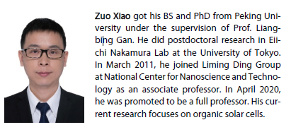
NEW CHANGE (1):
Short Bio along with ID photo for the first author and corresponding author are required and would be added at the end of the paper since January Issue 2021. It is optional for the other authors. The sample is attached.

NEW CHANGE (2):
The figures and images provided by the authors would be used directly in the full-text HTML file and PDF file. Each figure and image should be enough clear and has no weak portion. Preferred formats are .tiff, .pdf, .eps. The figures, images and the author's photo require CMKY color with a resolution of 300 – 600 dpi.
Specified requirements for figures and images could be found in the “Requirements of figures” file.

